UHD 无缝切换器/画面分割器

KVM切换器

版本：V1.5

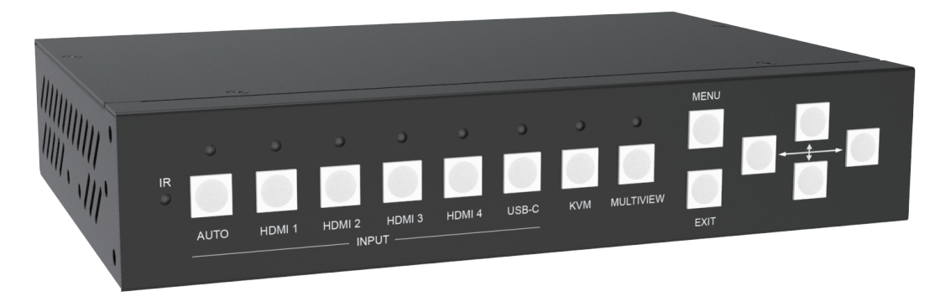

**warning警告**

* 请勿将本设备暴露在雨水、湿气和滴水中
* 请使用随机配送的附件
* 在闪电雷暴天气下，请拔掉电源
* 本说明书仅供参考， 如有更改恕不预先通知

内容

1. 特点 3

2. 面板布局 4

3. 遥控器 6

4. EDID 和HDCP 处理 6

5. 视频和音频 7

6. 多窗口 7

7. 鼠标跨屏和键盘热键 7

8. OSD 菜单导航 8

9. 规格 10

10. 包装 10

11. RS232 指令 10

System and IP command 11

Switching command, only available on SINGLE mode 12

Output command 12

Multiview command 13

Audio command 18

KVM command 18

EDID command 19

**介绍**

本5路视频输入2路HDMI 2.0并行输出的无缝切换器/画面分割器/KVM切换器支持最大输入/输出分辨率到3840x2160@60, 可以同时将多达4个窗口的画面显示在同一个显示屏上

支持4路 PC的USB- B 输入和两路USB-A输出，USB-A分别接键盘和鼠标

用户可以方便的通过前面板按键，遥控器，串口指令，TCP/IP指令来进行操作

HDMI B 并行输出口可以接到音频功放,视频采集卡,或HDBaseT延长器等

应用领域:

家庭影院; 视频会议; 安防监控; 演示广告; 教学系统; 金融分析; 电竞赛场; 医疗显示

# 特点

* 4x HDMI, 1x USB-C(仅视频) 输入，2x HDMI 并行输出
* 支持 HDMI 2.0,HDCP 2.2, 支持最大分辨率到3840x2160@60
* 支持5种多窗口模式, SINGLE, PIP, PBP, 3xWIN, 4xWIN
* 单窗口无缝切换，多窗口快速切换
* 支持音量控制和音频独立选择

支持 LPCM, AC3, DD+, DTS, DTS-HD, 最大到 7.1 声道

* 支持OSD 菜单导航
* 支持多种 EDID 和HDCP 操作
* 支持4路USB主设备输入和2路从设备（键盘,鼠标）输出

支持鼠标在多窗口显示模式下自动跨屏功能

# 面板布局

前面板

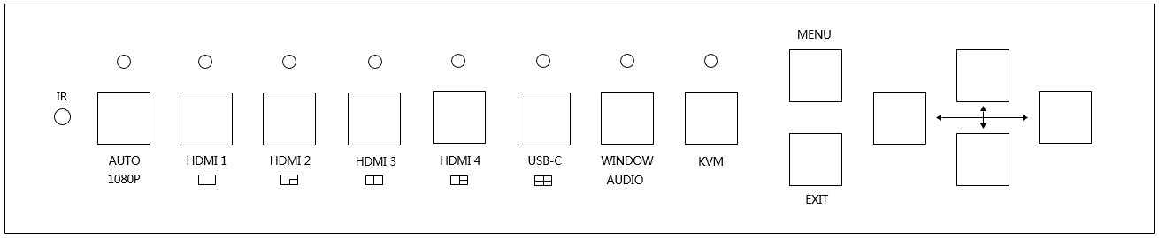

| **Name** | **Description** |
| --- | --- |
| **AUTO** | 按**AUTO** 键可以激活或关闭自动信源切换功能  该功能仅在单窗口模式下可以激活  长按该按键3秒，可切换输出分辨率为1080p60 |
| **HDMI 1, HDMI 2**  **HDMI 3, HDMI 4**  **USB-C** | 短按进行信号源选择  长按这4个按键3秒，可分别进入Single, PIP, PBP,3xWIN或4xWIN显示模式 |
| **WINDOW,**  **AUDIO** | 按下该按键, 屏幕上将显示一个窗口的边框， 循环按该按键将选择不同的窗口画面，然后按HDMI 1,2,3,4或USB-C键选择该窗口显示的信号源  长按该按键3秒，屏幕上将会显示音频选择的菜单，然后按上/下/左/右/确认键 进行音频选择 |
| **KVM** | 循环按下该按键, 屏幕上将在不同的窗口上显示一个边框, 最后停留边框的窗口即为切换到键盘鼠标的显示窗口 |
| **MENU,EXIT,** | OSD 菜单导航 |

Rear

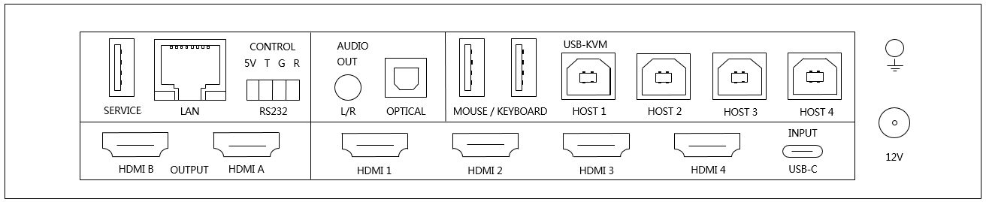

|  |  |
| --- | --- |
| **Name** | **Description** |
| **HDMI A, B** out | HDMI 输出，最大到 3840x2160@60 |
| **INPUT**s | HDMI 1, HDMI 2, HDMI 3, HDMI 4, USB-C(仅视频) |
| **USB-Service** | 固件升级用 |
| **LAN** | TCP/IP 控制. 默认参数如下  IP address: 192.168.0.247; Sub Mask: 255.255.255.0  GATEWAY: 192.168.0.1; NETPORT: 2000  所有参数都可以通过RS232命令更改 |
| **RS232** control | 4 口凤凰插端子  默认：Baud rate 9600, 8 data bits, 1 stop bit, no parity  Baud rate 可以通过OSD菜单更改  **5V**: 5V output;  **T**: Switcher PC  **R**: Switcher PC  **G**: Ground |
| **AUDIO OUTPUT** | 3.5mm L+R 输出, 20Hz ~ 20kHz, 1.5Vrms max;  Toslink-optical 输出 |
| **KVM** | 4x USB-B 口，接PC  2x USB-A 接键盘/鼠标  PC USB口与视频HDMI输入的绑定关系为：  HDMI 1<> Host 1, HDMI 2<> Host 2,  HDMI 3<> Host 3, HDMI 4<> Host 4, USB-C <> Host 4  HDMI 4和USB-C 共用Host 4作键盘鼠标操作 |
| **12V** | 12V电源适配器插入 |

# 遥控器

|  |  |
| --- | --- |
| **Number** | **Description** |
| **1** | 返回 |
| **2** | 输入 |
| **3** | OSD 菜单导航 |
| **4** | 窗口模式选择 |
| **5** | 音源选择 |
| **6** | KVM选择键 |

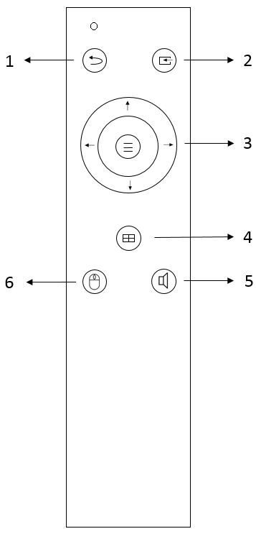

# EDID 和HDCP 处理

用户可以通过串口命令或OSD菜单选择以下EDID模式

|  |  |  |  |
| --- | --- | --- | --- |
| **Number** | **EDID mode** | **Number** | **EDID mode** |
| **1** | 4K60-2.0CH | 10 | 1600x1200 |
| **2** | 4K60-5.1CH | 11 | 1440x900 |
| **3** | 4K30-2.0CH | 12 | 1360x768 |
| **4** | 4K30-5.1CH | 13 | 1280x1024 |
| **5** | 1080P-2.0CH | 14 | 1024x768 |
| **6** | 1080P-5.1CH | 15 | AUTO |
| **7** | 720P | 16 | 4K60-7.1CH |
| **8** | 1920x1200 | 17 | 4K30-7.1CH |
| **9** | 1680x1050 | 18 | 1080P-7.1CH |
|  |  | 19 | USER |

HDMI输出支持3种HDCP选项: FORCE-1.4, FORCE-2.2, FORCE-OFF

用户可以通过RS232命令选择

# 视频和音频

切换器支持最大输入分辨率3840x2160@60, 支持多种音频格式，比如 LPCM, AC3, DD+, DTS, DTS-HD, 最大到7.1 声道， 支持音频独立选择

用户可以控制LPCM格式音频的音量

支持以下输出分辨率选择

|  |  |  |  |
| --- | --- | --- | --- |
| **Number** | **Output Resolution** | **Number** | **Output Resolution** |
| **1** | 4096x2160p 60Hz | 8 | 1920x1080p 60Hz |
| **2** | 4096x2160p 50Hz | 9 | 1920x1080p 50Hz |
| **3** | 3840x2160p 60Hz | 10 | 1360x768p 60Hz |
| **4** | 3840x2160p 50Hz | 11 | 1280x800p 60Hz |
| **5** | 3840x2160p 30Hz | 12 | 1280x720p 60Hz |
| **6** | 3840x2160p 25Hz | 13 | 1280x720p 50Hz |
| **7** | 1920x1200p60Hz RB | 14 | 1024x768 60Hz |

# 多窗口

支持5种多窗口模式

SINGLE, PIP, PBP, 3xWIN, 4xWIN

对于不同的多窗口模式，用户可以进行不同的操作

SINGLE: 信源选择

PIP: 信源选择, 显示比例, 子画面大小和位置

PBP, 3xWIN, 4xWIN: 信源选择, 显示比例,模式选择

默认布局如下

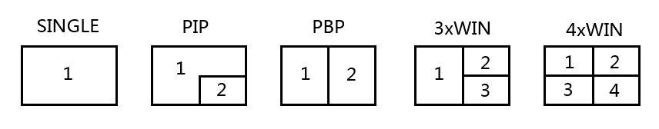

用户可以通过串口命令或OSD菜单进行选择

# 鼠标跨屏和键盘热键

鼠标跨屏功能仅在PBP, 3xWIN 或 4xWIN 显示模式下可以使用.

支持以下几种键盘热键操作

1. Ctrl + Ctrl + 1, 2, 3 或 4 切换键盘鼠标窗口
2. Ctrl + Ctrl + R + N, 关闭 USB 跨屏
3. Ctrl + Ctrl + R + Y, 打开USB 跨屏
4. Ctrl + Ctrl + M + 1,2,3,4 或5 切换显示模式到SINGLE,PIP,PBP,3xWIN或 4xWIN
5. Ctrl + Ctrl + W + m + S + n, 在窗口m上显示输入源n.

m 是窗口号, n 输入通道 ( 1 是HDMI 1 输入,…, 8 是 DP输入, 9是USB-C 输入).

1. Ctrl + Ctrl + A + n, n 为 1, 2, …5, 或 A, 选择音频源

1 表示HDMI 1, A 表示窗口1所对应的输入通道的音源

1. Ctrl + Ctrl + A + N, 静音
2. Ctrl + Ctrl + A + Y, 解除静音

请注意：

1. 上述的“+”表示操作上的先后顺序，不指具体的符号或字母
2. 按了键盘上的Ctrl + Ctrl 后，系统会进入热键等待阶段，如果在5秒钟之内

没有按完剩下的热键，热键组合将会超时退出

1. 按了键盘上的Ctrl + Ctrl 后，系统会进入热键等待阶段，如果在热键组合未

按完之前又按了Ctrl或ESC键，热键操作将会终止

# OSD 菜单导航

总共6个按键进行OSD菜单导航, 菜单/返回/上/下/左/右

菜单类容如下：

|  |  |  |  |
| --- | --- | --- | --- |
| 输出设置 | 分辨率 | 3840x2160p60 | 3840x2160p60,… |
| 无信号设置 | 黑屏, | 黑屏, 蓝屏 |
| 4K自动 | 开 | 开,关 |
| ITC | 关 | 开,关 |
| 多画面 | 单画面 | 输入选择 | HDMI1, … |
| PIP | 窗口1选择 | HDMI1,… |
| 窗口2选择 | HDMI1,… |
| PIP 位置 | 右下,右上,左上,左下 |
| PIP 大小 | 大,中,小 |
| PBP | 窗口1选择 | HDMI1,… |
| 窗口2选择 | HDMI1,… |
| 模式 | 1, 2 |
| 画面比例 | 全屏, 16:9 |
| 3xWIN | 窗口1选择 | HDMI1,… |
| 窗口2选择 | HDMI1,… |
| 窗口3选择 | HDMI1,… |
| 模式 | 1, 2 |
| 画面比例 | 全屏, 16:9 |
| 4xWIN | 窗口1选择 | HDMI1,… |
| 窗口2选择 | HDMI1,… |
| 窗口3选择 | HDMI1,… |
| 窗口4选择 | HDMI1,… |
| 模式 | 1, 2 |
| 画面比例 | 全屏,16:9 |
| 声音设置 | 音源选择 | 窗口1 | 窗口1,HDMI1,… |
| 音量 | 100 | 0..100 |
| 静音 | 关 | 开,关 |
| 系统设置 | Language/语言 | English | English, 中文 |
| EDID | 4K60-2.0 | 4K60-2.0,… |
| 鼠标跨屏 | OFF | ON, OFF |
| 波特率 | 9600 | 9600, 19200, 38400,57600, 115200 |
| 复位 |  |  |
| 固件版本 |  | Read only |
| IP地址 |  | Read only |

请注意：

1. 鼠标跨屏功能仅能在PBP, 3xWIN 或 4xWIN 显示模式下可以被激活.

就KVM鼠标键盘而言,HDMI 4和USB-C是相同的信号源

以4xWIN为例：

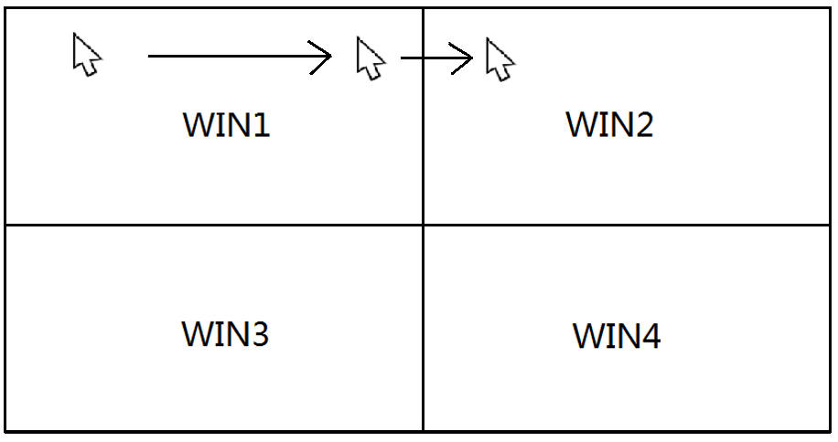

1. 关于ITC 的设置, 建议视频信源时设置为**关**，PC界面尤其是电脑桌面用**开**，for 默认**关**

# 规格

|  |  |
| --- | --- |
| 带宽 | 594MHz (18Gbps), HDMI 2.0, HDCP2,2 |
| 音频格式 | LPCM, AC3, DD+, DTS, DTS-HD  Up to 7.1 channel |
| 输入口 | 4x HDMI |
| 输出口 | 1x HDMI  1x 3.5mm LR audio  1x Toslink digital audio |
| 电源 | 12V/3A ,15W max |
| 工作温度 | 0 to +40°C (+32 to +104 °F) |
| 工作湿度 | 10 to 70 % RH (non-condensing) |
| ESD | Air: ± 8KV, Contact: ± 4KV, |
| 尺寸 | L219 x W146 x H44 mm |
| 重量 (Main Unit) | 1.2kg |

# 包装

|  |  |
| --- | --- |
| **项目** | **Quantity** |
| 主机 | 1 |
| 12V/3A 电源适配器 | 1 |
| 4口凤凰插公头 | 1 |
| 用户手册 | 1 |
| 遥控器 | 1 |
| 支架 | 2 |

# RS232 指令

**Note:** All the commands begin with SET or GET, end with Carriage Return (CR).

⮠ Represents Carriage Return (CR). All return messages are always end with CR.

## System and IP command

|  |  |
| --- | --- |
| Command | Details |
| GET HELP⮠ | Get the Commands list |
| SET RESET⮠ | Recover to default setting |
| GET VERSION⮠ | Get firmware version  Return: VERSION w (w is version number) |
| SET BAUDRATE w⮠ | w is 9600, 19200, 38400,57600 or 115200  Return: BAUDRATE w |
| GET BAUDRATE w⮠ | Return: BAUDRATE w |
| SET IP ADDRESS w⮠ | For example: SET IP ADDRESS 192.168.0.247  Return: IP ADDRESS w |
| GET IP ADDRESS⮠ | Return: IP ADDRESS w |
| SET SUBMASK w⮠ | For example: SET SUBMASK 255.255.255.0  Return: SUBMASK w |
| GET SUBMASK⮠ | Return: SUBMASK w |
| SET GATEWAY w⮠ | For example: SET GATEWAY 192.168.0.1  Return: GATEWAY w |
| GET GATEWAY⮠ | Return: GATEWAY w |
| SET NETPORT w⮠ | For example: SET NETPORT 2000  Return: NETPORT w |
| GET NETPORT⮠ | Return: NETPORT w |
| SET NETWORK-INFO IP PORT SUBMASK GATEWAY⮠ | For Example:  SET NETWORK-INFO 192.168.0.247 2000 255.255.255.0 192.168.0.1  Return: NETWORK-INFO 192.168.0.247 2000 255.255.255.0 192.168.0.1 |
| GET NETWORK-INFO⮠ | Return: NETWORK-INFO IP PORT SUBMASK GATEWAY |

## Switching command, only available on SINGLE mode

|  |  |
| --- | --- |
| Commands | Details |
| SET AUTO SWITCH w⮠ | w is ON or OFF, default OFF  Return: AUTO SWITCH w |
| GET AUTO SWITCH⮠ | Return: AUTO SWITCH w |
| SET IN SOURCE w⮠ | w is one of the following:  HDMI1, HDMI2, HDMI3, HDMI4, USB-C  Return: IN SOURCE w |
| GET IN SOURCE⮠ | Get current input channel selection information  Return: IN SOURCE w |
| GET IN RESOLUTION⮠ | Get current input resolution  Return: IN RESOLUTION w (w is input resolution) |
| GET IN STATUS⮠ | Get status of all input ports  x is HDMI1…HMDI4,USB-C  Return: IN STATUS x VALID(or INVALID)  If input port is vaild,  Return: IN STATUS x InputRes ColorSpace ColorDepth |

## Output command

|  |  |
| --- | --- |
| Commands | Details |
| SET OUT RESOLUTION w⮠ | w is one of the following, default: 3840x2160p60  4096x2160p60, 4096x2160p50,  3840x2160p60, 3840x2160p50,  3840x2160p30, 3840x2160p25,  1920x1200p60RB, 1920x1080p60,  1920x1080p50, 1360x768p60,  1280x800p60, 1280x720p60,  1280x720p50, 1024x768p60，  AUTO, USER  Return: OUT RESOLUTION w |
| GET OUT RESOLUTION⮠ | Get current output resolution setting  Return: OUT RESOLUTION w |
| SET RESO-USER Width Height⮠ | Set user define output resolution  Width is horizontal active pixels  Height is vertical active lines  For user define output resolution,the frame rate is always 60Hz  Return: RESO-USER Width Height⮠ |
| GET RESO-USER⮠ | Return: RESO-USER Width Height⮠ |
| SET OUT 4K-AUTO w⮠ | w is ON or OFF, default ON  If we set 4K output to a displayer which can’t support 4K, then the ON setting can change the resolution to 1080p or 4K-4:2:0  Return: OUT 4K-AUTO w |
| GET OUT 4K-AUTO⮠ | Get current OUT 4K-AUTO mode  Return: OUT 4K-AUTO w |
| SET OUT HDCP w⮠ | w is one of the following, default OFF  FORCE-1.4,FORCE-2.2,FORCE-OFF  Return: OUT HDCP w |
| GET OUT HDCP⮠ | Return: OUT HDCP w |
| SET OUT VKA w⮠ | w is BLUESCREEN or BLACKSCREEN.  Default BLACKSCREEN. It is for no signal display  Return: OUT VKA w |
| GET OUT VKA⮠ | Return: OUT VKA w |
| SET OUT ITC w⮠ | w is ON or OFF, default OFF  Return: OUT ITC w |
| GET OUT ITC⮠ | Return: OUT ITC w |

## Multiview command

|  |  |
| --- | --- |
| Commands | Details |
| SET MULTIVIEW w⮠ | Select one Multiview mode for current display  w is one of the following, default SINGLE  SINGLE C:\Users\windows7\AppData\Local\Temp\1629080528(1).png, PIP , PBPC:\Users\windows7\AppData\Local\Temp\1629081546(1).png, 3xWIN C:\Users\windows7\AppData\Local\Temp\1629082712(1).png, 4xWIN C:\Users\windows7\AppData\Local\Temp\1629082974(1).png  Return: MULTIVIEW w |
| GET MULTIVIEW⮠ | Get the current Multiview mode  Return: MULTIVIEW w |
| SET WINDOWx IN y⮠ | Select one input for one display window for the current Multiview mode. x is one of 1, 2, 3 or 4  y is one of HDMI1, HDMI2, HDMI3, HDMI4, USB-C  Return: WINDOWx IN y |
| GET WINDOWx IN⮠ | This command to get which is the input source for one display window for the current Multiview mode  Return: WINDOWx IN y |
| SET FREEZE-WINx w | Freeze the display window,x is one of 1, 2, 3 ,4 or ALL, w is ON or OFF  Return: FREEZE-WINx w |
| GET FREEZE-WINx | x is one of 1, 2, 3 ,4.  Return: FREEZE-WINx w (w is ON or OFF) |
| SET PIP POS w⮠ | This command to select the PIP sub window position.  w is one of the following, default RightBottom  LeftTop, LeftBottom, RightTop, RightBottom,USER  Return: PIP POS w |
| GET PIP POS⮠ | This command to get the PIP sub window position  Return: PIP POS w |
| SET PIP SIZE w⮠ | This command to select the PIP sub window size.  w is one of the following, default LARGE  SMALL,MIDDLE, LARGE, USER  Return: PIP SIZE w |
| GET PIP SIZE⮠ | Return: PIP SIZE w |
| SET PIP USER HStart VStart HSize VSize⮠ | Return: PIP USER HStart VStart HSize VSize  This command allows users to customize a PIP layout include sub window position and size.  This customized PIP layout will replace other pre-defined PIP modes (such as LeftTop,LARGE) and display on the screen  After the user enters SET PIP POS or SET PIP SIZE command,the PIP USER will become invalid    Please note  HStart plus HSize less than or equal to 101  VStart plus VSize less than or equal to 101 |
| GET PIP USER⮠ | Return: PIP USER HStart VStart HSize VSize |
| SET PBP MODE w⮠ | Set the PBP display mode  w is one of 1,2 or 3, default 1    Return: PBP MODE w  Please note for PBP mode 3, window2 can capture part of the input image area. It is main used for presenter show when work with conference camera situations  The capture area can be defined by SET PBP-PRESENTER command |
| GET PBP MODE⮠ | Return: PBP MODE w |
| SET PBP ASPECT w⮠ | Set the PBP window display aspect  w is FULL or 16:9, default FULL    Return: PBP ASPECT w |
| GET PBP ASPECT⮠ | Return: PBP ASPECT w |
| SET PBP-PRESENTER HStart VStart HSize VSize⮠ | Set window 1 capture area for PBP mode 3  This command only valid when the switcher already work on PBP mode 3  Return: PBP-PRESENTER HStart VStart HSize VSize    Default HStart 38, VStart 13, HSize 25, VSize 75  Please note  HStart plus HSize less than or equal to 101  VStart plus VSize less than or equal to 101 |
| GET PBP-PRESENTER⮠ | Return: PBP-PRESENTER HStart VStart HSize VSize |
| SET 3xWIN MODE w⮠ | Set the 3xWIN display mode  w is one of 1,2,3 or 4, default 1  C:\Users\windows7\AppData\Local\Temp\1658982390(1).png  Return: 3xWIN MODE w |
| GET 3xWIN MODE⮠ | Return: 3xWIN MODE w |
| SET 3xWIN ASPECT w⮠ | Set the 3xWIN window display aspect  w is FULL or 16:9, default FULL  C:\Users\windows7\AppData\Local\Temp\1658982480(1).png  Return: 3xWIN ASPECT w |
| GET 3xWIN ASPECT⮠ | Return: 3xWIN ASPECT w |
| SET 4xWIN MODE w⮠ | Set the 4xWIN display mode  w is 1 or 2 ,default 1    Return: 4xWIN MODE w |
| GET 4xWIN MODE⮠ | Return: 4xWIN MODE w |
| SET 4xWIN ASPECT w⮠ | Set the 4xWIN window display aspect  w is FULL or 16:9, default FULL  C:\Users\windows7\AppData\Local\Temp\1637116792(1).png  Return: 4xWIN ASPECT w |
| GET 4xWIN ASPECT⮠ | Return: 4xWIN ASPECT w |
| GET MULTIVIEW-SYNC⮠ | Return Multiview layout information |
| SET SAVE SCENE w⮠ | Save current display scene  w is 1, 2,…20  Return: SAVE SCENE w |
| SET LOAD SCENE w⮠ | Load display scene  w is 1, 2,…20  Return: LOAD SCENE w |

## Audio command

|  |  |
| --- | --- |
| Commands | Details |
| SET AUDIO SOURCEw⮠ | w is one of the following:  WIN1, HDMI1, HDMI2, HDMI3, HDMI4, USB-C  Return: AUDIO SOURCE w |
| GET AUDIO SOURCE⮠ | Return: AUDIO SOURCE w |
| SET AUDIO VOL+⮠ | Increase audio out volume  Return: AUDIO VOL w (w is the volume value) |
| SET AUDIO VOL-⮠ | Decrease audio out volume  Return: AUDIO VOL w (w is the volume value) |
| SET AUDIO VOL w⮠ | Set audio volume value  w is 0,1…,or 100, default 100  For example: SET AUDIO VOL 100  Return: AUDIO VOL w |
| GET AUDIO VOL⮠ | Return: AUDIO VOL w |
| SET AUDIO-MUTE w⮠ | Mute or unmute audio output  Here w is ON or OFF, default OFF  Return: AUDIO-MUTE w |
| GET AUDIO-MUTE⮠ | Return: AUDIO-MUTE w |

## KVM command

|  |  |
| --- | --- |
| Commands | Details |
| SET KVMw⮠ | w is one of WIN1, WIN2, WIN3, WIN4  Return: KVM w |
| SET USB ROAMINGw⮠ | w is ON or OFF, default OFF  Return: USB ROAMING w |
| GET USB ROAMING ⮠ | Return: USB ROAMING w |

Please note when work on SINGLE display mode, the KVM function of current selected source is always activated

## EDID command

The following commands are used to set EDID mode for the inputs

|  |  |
| --- | --- |
| Commands | Details |
| SET IN EDIDMODE w⮠ | w is one of the following:  4K60-2.0, 4K60-5.1, 4K60-7.1, 4K30-2.0,  4K30-5.1, 4K30-7.1, 1080p60-2.0,1080p60-5.1,  1080p60-7.1,1920x1200, 1680x1050, 1600x1200, 1440x900, 1360x768, 1280x1024, 1024x768, 720p, AUTO,USER  Default: 4K60-2.0  Return: IN EDIDMODE w |
| SET EDID-USER w⮠ | Switcher can only support 256 bytes EDID-USER data.  w is 256 bytes EDID data.  Return: EDID-USER OK |
| GET IN EDIDMODE⮠ | Return: IN EDIDMODE w |