超高清无缝切换器/画面分割器/KVM控制器

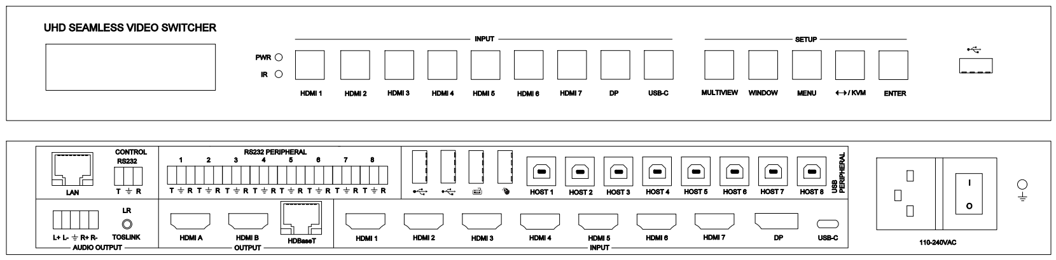

**warning警告**

* 请勿将本设备暴露在雨水、湿气和滴水中
* 只能使用制造商指定的附件
* 在雷暴期间拔下此设备
* 说明书仅供参考，如有更改恕不预先通知

内容

1. 特点 3

2. 面板 4

3. EDID and HDCP 处理 5

4. 视频和音频 6

5. 多窗口 6

6. USB 鼠标跨屏和键盘热键 6

7. 遥控器 8

8. OSD 菜单 9

9. 规格 11

10. 包装 11

11. RS232 指令 11

System command 11

Switching command, only available on SINGLE mode 13

Output command 13

Multiview command 15

Audio command 18

KVM command 19

EDID command 19

RS232-peripheral command 20

**介绍**

本款产品是一种多格式超高清视频无缝切换器，画面分割器及KVM控制器. 支持7路HDMI 2.0输入，1路DP 1.2输入， 一路USB-C(仅视频和音频)输入. 3路超高清并行输出，含两路HDMI 2.0和1路HDBaseT输出.

本产品集成了8路USB-HOST输入，3路USB 2.0输出口以及键盘/鼠标USB接入口；

提供 8路 外围RS232口, 用户可以选择某一路RS232口的通断从而控制不同的设备

本产品支持最多四个窗口画面的信号同时显示在一个显示设备上

用户可以很方便的通过前面板按键,遥控器，RS232或TCP/IP指令实现人机交互

# 特点

* 输入：7 HDMI, 1 DP 1.2, 1 USB-C (仅视频和音频)
* 输出：3路并行输出 – HDMI A, HDMI B 和HDBaseT
* HDBaseT 传输距离：70m@4K; 100m@1080p60
* 8路USB 主设备输入, 5路USB 从设备输出 (含键盘和鼠标各一个USB口)
* 输入输出均支持 HDMI 2.0/HDCP 2.2, 视频最大分辨率3840x2160p60
* 支持SINGLE（单画面）, PIP, PBP, 3xWIN, 4xWIN 多窗口显示模式
* 提供20种场景的保存和调用
* 单窗口显示时，信源无缝切换，多窗口时快速切换
* 支持音量控制(仅LPCM模式)和音频独立选择
* 输入口HDMI 1，2，3支持 LPCM, AC3, DD+, DTS, DTS-HD
* 支持USB鼠标跨屏和其它KVM控制
* 提供模拟音频平衡输出和SPDIF数字音频输出
* 提供8路RS232外围设备控制口
* 支持多种Test Pattern测试卡输出
* 支持给HDBaseT 接收器提供24V iPOC供电
* 支持OSD菜单导航

# 面板

前面板

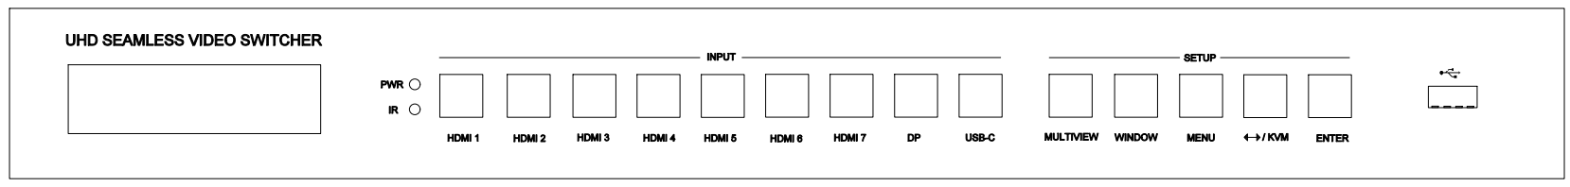

| **Name** | **描述** |
| --- | --- |
| **PWR** | 电源指示灯,当设备上电时电源指示灯点亮 |
| **IR** | 遥控接收头，预留 |
| **HDMI 1, 2…,7,**  **DP, USB-C** | 9路视频输入源选择按键 |
| **MULTIVIEW** | 连续按该按键，循环切换PIP**,**PBP**,**3xWIN**,**4xWIN显示模式 |
| **WINDOW** | 按该按键，屏幕上窗口1位置会有一黄色边框，继续按此键，黄色边框会依次出现在窗口2，… 然后按某个输入按键，比如HDMI 1键， 会将HDMI 1信号显示在当前选定的窗口上. |
| **MENU**  **↔/KVM**  **ENTER** | 三个系统设置按键，配合前面板显示屏，可实现下列设置:   1. 测试卡开关 2. KVM边框开关 3. USB鼠标跨屏开关 4. Auto Switch 自动切换开关 5. Long Reach模式开关 6. 输出分辨率选择 7. EDID选择 8. COMP Mode ：DSC,CSC.   在4K60输出分辨率时，HDBT的压缩传输模式   1. RS232波特率选择 2. IP地址信息显示 3. 软件版本显示   在无其他操作的情况下直接按↔/KVM 键可以切换键盘鼠标在不同的显示窗口上 |
| 1678681945015 | 第三路USB口 |

后面板

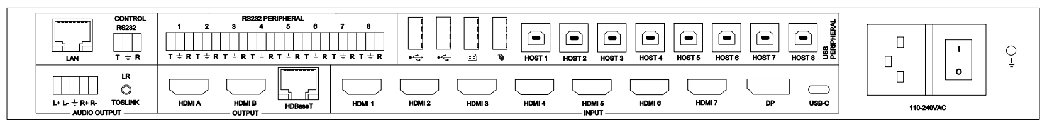

|  |  |
| --- | --- |
| **Name** | **Description** |
| **Audio outputs** | 左右声道平衡输出，凤凰插  3.5mm 左右声道输出,  SPDIF光信号输出 |
| **Outputs** | 输出：HDMI A, HDMI B, HDBaseT |
| **INPUT**s | 输入：HDMI 1, …, HDMI 7, DP, USB-C |
| **LAN** | TCP/IP 控制. 默认参数如下  IP address: 192.168.0.247; Sub Mask: 255.255.255.0  GATEWAY: 192.168.0.1; NETPORT: 2000  所有参数都可以通过RS232命令更改 |
| **RS232 control** | 3 口凤凰插端子  默认：Baud rate 9600, 8 data bits, 1 stop bit, no parity  Baud rate 可以通过前面板来更改  **T**: Switcher PC  **G**: Ground  **R**: Switcher PC |
| **RS232-peripheral,**  **8 ports** | 8路外围RS232控制口，对应IN1，IN2...IN9  IN8为DP, IN9为USB-C， DP与USB-C设备共用RS232-8 |
|  | 接入USB 2.0设备 |
|  | 接入键盘鼠标 |
| **8 USB-Host** | 8路USB-HOST信号，对应IN1,IN2...,IN9.  IN8为DP, IN9为USB-C，DP与USB-C设备共用HOST8 |

# EDID and HDCP 处理

用户可以通过RS232命令或前面板按键键/显示屏实现以下EDID选择

|  |  |  |  |
| --- | --- | --- | --- |
| **Number** | **EDID mode** | **Number** | **EDID mode** |
| **1** | 4K60-2.0CH | 10 | 1600x1200 |
| **2** | 4K60-5.1CH | 11 | 1440x900 |
| **3** | 4K30-2.0CH | 12 | 1360x768 |
| **4** | 4K30-5.1CH | 13 | 1280x1024 |
| **5** | 1080P-2.0CH | 14 | 1024x768 |
| **6** | 1080P-5.1CH | 15 | AUTO |
| **7** | 720P | 16 | 4K60-7.1CH |
| **8** | 1920x1200 | 17 | 4K30-7.1CH |
| **9** | 1680x1050 | 18 | 1080P-7.1CH |
|  |  | 19 | USER |

HDMI输出支持3种HDCP选择: FORCE-1.4, FORCE-2.2, FORCE-OFF

用户可以通过RS232指令进行设置

# 视频和音频

支持音频独立选择,用户可以控制LPCM格式音频的音量

有以下的音频源选项

WIN1, WIN-KVM, HDMI1, HDMI2, …,HDMI7, DP, USB-C.

WIN-KVM 表示声音始终选择被选中的KVM窗口所对应的输入源

WIN1 表示声音始终选择窗口1所对应的输入源

其中输入口HDMI1,2,3支持多种音频格式，比如 LPCM, AC3, DD+, DTS, DTS-HD

切换器支持最大输入分辨率3840x2160@60, 支持以下输出分辨率选择

|  |  |  |  |
| --- | --- | --- | --- |
| **Number** | **Output Resolution** | **Number** | **Output Resolution** |
| **1** | 4096x2160p 60Hz | 8 | 1920x1080p 60Hz |
| **2** | 4096x2160p 50Hz | 9 | 1920x1080p 50Hz |
| **3** | 3840x2160p 60Hz | 10 | 1360x768p 60Hz |
| **4** | 3840x2160p 50Hz | 11 | 1280x800p 60Hz |
| **5** | 3840x2160p 30Hz | 12 | 1280x720p 60Hz |
| **6** | 3840x2160p 25Hz | 13 | 1280x720p 50Hz |
| **7** | 1920x1200p60Hz RB | 14 | 1024x768 60Hz |

# 多窗口

支持5种多窗口模式: SINGLE, PIP, PBP, 3xWIN, 4xWIN

对于不同的多窗口模式，用户可以进行如下不同的操作:

SINGLE: 信源选择

PIP: 信源选择, 子画面大小和位置

PBP, 3xWIN, 4xWIN: 信源选择, 显示比例,模式选择

默认布局如下

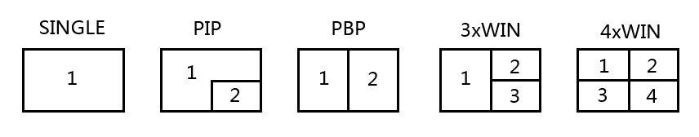

用户可以通过串口命令实现多种格式的画面布局，支持多达20种场景的存储或调用

# USB 鼠标跨屏和键盘热键

鼠标跨屏功能仅在PBP, 3xWIN 或 4xWIN 显示模式下可以使用.

支持以下几种键盘热键操作

1. Ctrl + Ctrl + 1, 2, 3 或 4 切换键盘鼠标窗口
2. Ctrl + Ctrl + Q

如果当前显示模式为PIP, PBP, 3xWIN,或4xWIN时，按这组热键切换到当前KVM窗口所对应的输入源的单窗口显示状态

如果当前工作模式为单画面模式，按这组热键切换到上一次多画面 (PIP, PBP,

3xWIN, 或4xWIN) 显示状态， 包含上一次多画面KVM窗口的信息

1. Ctrl + Ctrl + R + N, 关闭 USB 跨屏
2. Ctrl + Ctrl + R + Y, 打开USB 跨屏
3. Ctrl + Ctrl + M + 1,2,3,4 或5 切换显示模式到SINGLE,PIP,PBP,3xWIN或 4xWIN
4. Ctrl + Ctrl + W + m + S + n, 在窗口m上显示输入源n.

m 是窗口号, n 输入通道 ( 1 是HDMI 1 输入,…, 8 是 DP输入, 9是USB-C 输入).

1. Ctrl + Ctrl + C + 1, 2, 3…9,0, 调用预存的某个场景为当前显示场景

0 表示场景10

1. Ctrl + Ctrl + S + 1, 2, 3…9,0, 存储当前场景

0 表示场景10

1. Ctrl + Ctrl + A + n, n 为 0,1, 2, 3…8, 9 or A, 选择音频源

0 表示选中的KVM窗口所对应的输入通道的音源 , 1 表示HDMI 1,

8 表示 DP, 9 表示USB-C, A 表示窗口1所对应的输入通道的音源

1. Ctrl + Ctrl + A + N, 静音
2. Ctrl + Ctrl + A + Y, 解除静音

请注意：

1. 上述的“+”表示操作上的先后顺序，不指具体的符号或字母
2. 按了键盘上的Ctrl + Ctrl 后，系统会进入热键等待阶段，如果在5秒钟之内

没有按完剩下的热键，热键组合将会超时退出

1. 按了键盘上的Ctrl + Ctrl 后，系统会进入热键等待阶段，如果在热键组合未

按完之前又按了Ctrl或ESC键，热键操作将会终止

# 遥控器

|  |  |
| --- | --- |
| **序号** | **描述** |
| **1** | 返回/退出 |
| **2** | 输入源选择 |
| **3** | OSD 菜单导航.  单独按左或右方向键时可以减小或增大音量 |
| **4** | 多画面模式选择 |
| **5** | 音源选择 |
| **6** | KVM窗口选择键 |

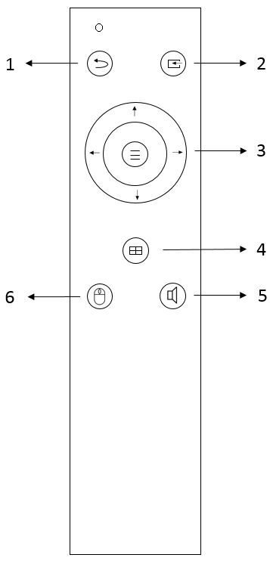

# OSD 菜单

总共4类OSD内容: 输出设置, 多画面显示, 音频设置, 系统设置

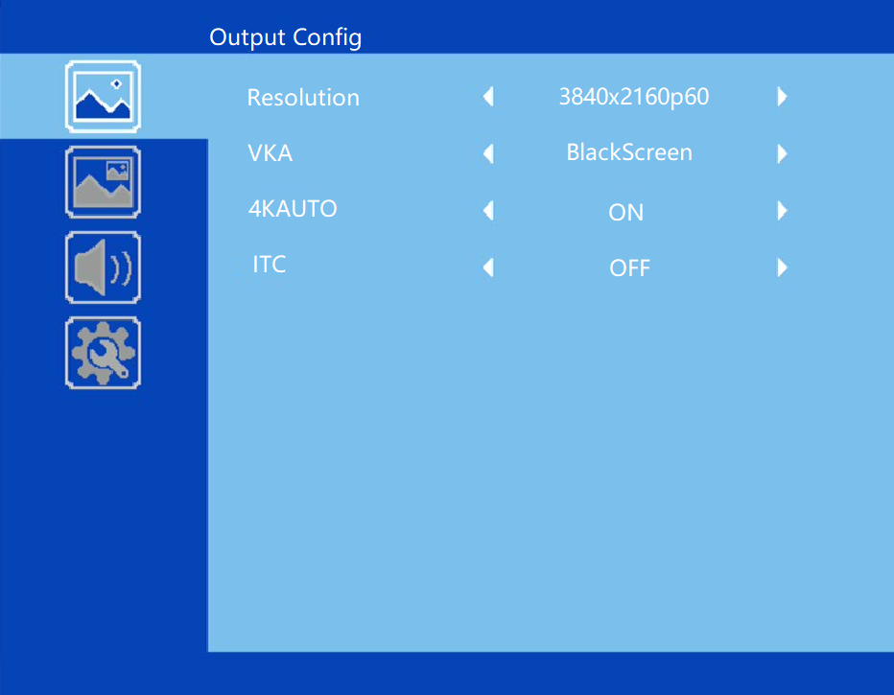

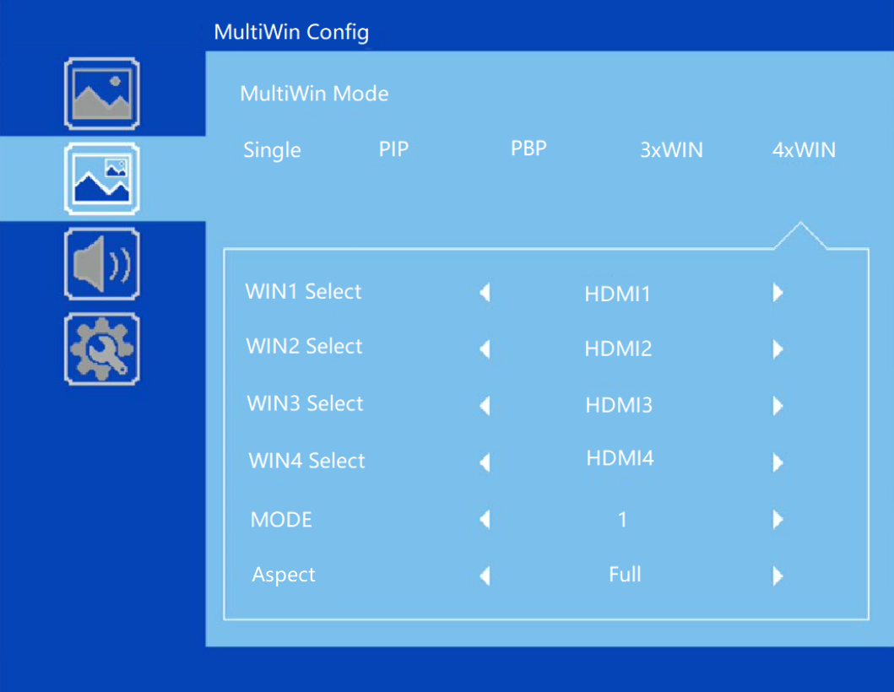

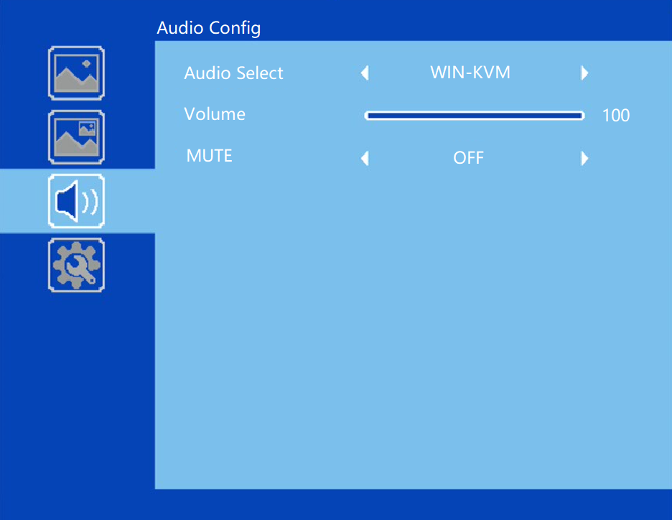

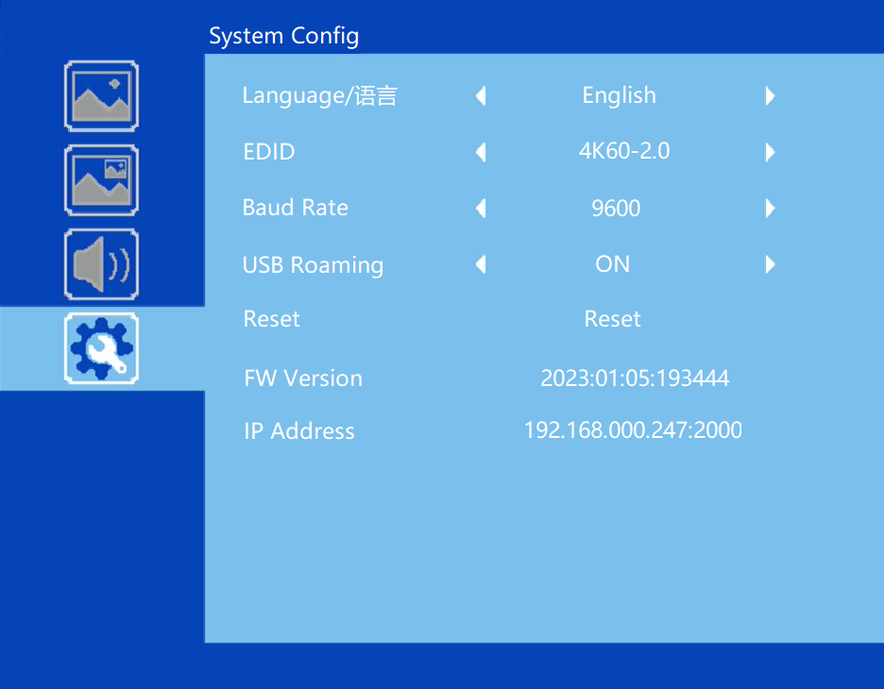

# 规格

|  |  |
| --- | --- |
| 带宽 | 594MHz (18Gbps), HDMI 2.0, HDCP2,2 |
| 音频格式 | LPCM, AC3, DD+, Up to 7.1 channel |
| 输入 | 7 HDMI, 1 DP, 1 USB-C |
| 输出 | 2 HDMI, 1 HDBaseT  1 平衡音频输出  1 迷你Toslink输出(3.5mm+Spdif) |
| 电源 | 110-220VAC |
| 工作温度 | 0 to +40°C (+32 to +104 °F) |
| 工作湿度 | 10 to 70 % RH (non-condensing) |
| ESD | Air: ± 8KV, Contact: ± 4KV, |
| 尺寸 | L430 x W220 x H44 mm |
| 重量 | 5kg |

# 

# 包装

|  |  |
| --- | --- |
| **内容** | **数量** |
| 切换器主机 | 1 |
| 遥控器 | 1 |
| 电源线 | 1 |
| 用户手册 | 1 |
| 3 口 凤凰插公头 | 9 |
| 5 口 凤凰插公头 | 1 |

# RS232 指令

所有的命令都以 SET 或 GET开始, 以换行符 CR 结束

⮠ 代表换行符CR

所有返回的信息都以CR结束

## System command

|  |  |
| --- | --- |
| Command | Details |
| GET HELP⮠ | Get the Commands list |
| SET RESET⮠ | Recover to default setting |
| GET VERSION⮠ | Get main firmware version  Return: VERSION w (w is version number) |
| GET SUB-VERSION⮠ | Get ARM firmware version  Return: SUB-VERSION w (w is version number) |
| GET EXPAND-VERSION⮠ | Get USB-SOC firmware version  Return: EXPAND-VERSION w (w is version number) |
| GET KEYBOARD-VERSION⮠ | Get front panel keyboard firmware version  Return: KEYBOARD-VERSION w (w is version number) |
| SET BAUDRATE w⮠ | w is 9600, 19200, 38400,57600 or 115200  Return: BAUDRATE w |
| GET BAUDRATE⮠ | Return: BAUDRATE w |
| SET IP ADDRESS w⮠ | For example: SET IP ADDRESS 192.168.0.247  Return: IP ADDRESS w |
| GET IP ADDRESS⮠ | Return: IP ADDRESS w |
| SET SUBMASK w⮠ | For example: SET SUBMASK 255.255.255.0  Return: SUBMASK w |
| GET SUBMASK⮠ | Return: SUBMASK w |
| SET GATEWAY w⮠ | For example: SET GATEWAY 192.168.0.1  Return: GATEWAY w |
| GET GATEWAY⮠ | Return: GATEWAY w |
| SET NETPORT w⮠ | For example: SET NETPORT 2000  Return: NETPORT w |
| GET NETPORT⮠ | Return: NETPORT w |
| SET NETWORK-INFO IP PORT SUBMASK GATEWAY⮠ | For Example:  SET NETWORK-INFO 192.168.0.247 2000 255.255.255.0 192.168.0.1  Return: NETWORK-INFO 192.168.0.247 2000 255.255.255.0 192.168.0.1 |
| GET NETWORK-INFO⮠ | Return: NETWORK-INFO IP PORT SUBMASK GATEWAY |
| SET LONG-REACH w⮠ | w is ON or OFF |
| GET LONG-REACH⮠ | Return: LONG-REACH w |
| SET FREEZE-WINx w | Freeze the display window,x is one of 1, 2, 3 ,4 or ALL, w is ON or OFF  Return: FREEZE-WINx w |
| GETFREEZE-WINx | x is one of 1, 2, 3 ,4.  Return: FREEZE-WINx w (w is ON or OFF) |

## Switching command, only available on SINGLE mode

|  |  |
| --- | --- |
| Commands | Details |
| SET AUTO SWITCH w⮠ | w is ON or OFF, default OFF  Return: AUTO SWITCH w |
| GET AUTO SWITCH⮠ | Return: AUTO SWITCH w |
| SET IN SOURCE w⮠ | w is one of the following:  HDMI1, HDMI2,…HDMI7,DP,USB-C  Return: IN SOURCE w |
| GET IN SOURCE⮠ | Get current input channel selection information  Return: IN SOURCE w |
| GET IN RESOLUTION⮠ | Get current input resolution  Return: IN RESOLUTION w (w is input resolution) |
| GET IN STATUS⮠ | Get status of all input ports  x is HDMI1…..HMDI7,DP,USB-C  Return: IN STATUS x VALID(or INVALID)  If input port is vaild,  Return: IN STATUS x InputRes ColorSpace ColorDepth |

## Output command

|  |  |
| --- | --- |
| Commands | Details |
| SET OUT RESOLUTION w⮠ | w is one of the following, default: 3840x2160p60  4096x2160p60, 4096x2160p50,  3840x2160p60, 3840x2160p50,  3840x2160p30, 3840x2160p25,  1920x1200p60RB, 1920x1080p60,  1920x1080p50, 1360x768p60,  1280x800p60, 1280x720p60,  1280x720p50, 1024x768p60，  AUTO, USER  Return: OUT RESOLUTION w |
| GET OUT RESOLUTION⮠ | Get current output resolution setting  Return: OUT RESOLUTION w |
| SET RESO-USER Width Height⮠ | Set user define output resolution,  Width is horizontal active pixels  Height is vertical active lines  For user define output resolution,the frame rate is always 60Hz  Return: RESO-USER Width Height⮠ |
| GET RESO-USER⮠ | Return: RESO-USER Width Height⮠ |
| SET OUT HDCP w⮠ | w is one of following, default FORCE-OFF  FORCE-1.4,FORCE-2.2,FORCE-OFF  Return: OUT HDCP w |
| SET OUT COMP w⮠ | w is CSC or DSC, default CSC  Compression mode when HDBT output resolution is 4K60  Return: OUT COMP w |
| GET OUT COMP⮠ | Return: OUT COMP w |
| GET OUT HDCP⮠ | Return: OUT HDCP w |
| SET OUT VKA w⮠ | Set video keep alive mode  w is BLUESCREEN or BLACKSCREEN.  Default BLACKSCREEN. It is for no signal display  Return: OUT VKA w |
| GET OUT VKA⮠ | Return: OUT VKA w |
| SET OUT 4K-AUTO w⮠ | w is ON or OFF, default ON  If we set 4K output to a displayer which can’t support 4K, then the **ON** setting can change the resolution to 1080p or 4K-4:2:0  Return: OUT 4K-AUTO w |
| GET OUT 4K-AUTO⮠ | Get current OUT 4K-AUTO mode  Return: OUT 4K-AUTO w |
| SET OUT ITC w⮠ | w is ON or OFF, default OFF  Return: OUT ITC w  Suggest **OFF** for video display and **ON** for PC especially desktop display, default **OFF** |
| GET OUT ITC⮠ | Return: OUT ITC w |
| SET OUT TSP w⮠ | Set Test Pattern on or off, w is ON or OFF  Return: OUT TSP w |
| GET OUT TSP⮠ | Return: OUT TSP w |
| SET OUT TSP-COLOR w⮠ | Set Test Pattern Colour , w is one of the following:  BLACK, BLUE, GREEN, RED, WHITE, PRBS,RAMP, CHECKER_BOARD, STRIPE, RED_RAMP, GREEN_RAMP, BLUE_RAMP  Default: CHECKER_BOARD  Return: OUT TSP-COLOR w |
| SET OUT TSP-TIMING w⮠ | Set output timing for Test Pattern display  w is one of the following:  4K30,1080p60, 720p60  default 1080p60  Return: OUT TSP-TIMING w |
| GET OUT TSP-TIMING⮠ | Return: OUT TSP-TIMING w |

## Multiview command

|  |  |
| --- | --- |
| Commands | Details |
| SET MULTIVIEW w⮠ | Select one Multiview mode for current display  w is one of the following, default SINGLE  SINGLE C:\Users\windows7\AppData\Local\Temp\1629080528(1).png, PIP , PBPC:\Users\windows7\AppData\Local\Temp\1629081546(1).png, 3xWIN C:\Users\windows7\AppData\Local\Temp\1629082712(1).png, 4xWIN C:\Users\windows7\AppData\Local\Temp\1629082974(1).png  Return: MULTIVIEW w |
| GET MULTIVIEW⮠ | Get the current Multiview mode  Return: MULTIVIEW w |
| SET SAVE SCENE w⮠ | Save current display scene  w is 1, 2,…20  Return: SAVE SCENE w |
| SET LOAD SCENE w⮠ | Load display scene  w is 1, 2,…20  Return: LOAD SCENE w |
| SET WINDOWx IN y⮠ | Select one input for one display window for the current Multiview mode. x is one of 1, 2, 3 or 4  y is one of HDMI1, HDMI2, …, HDMI7, DP,USB-C  Return: WINDOWx IN y |
| GET WINDOWx IN⮠ | This command to get which is the input source for one display window for the current Multiview mode  Return: WINDOWx IN y |
| SET PIP POS w⮠ | This command to select the PIP sub window position.  w is one of the following, default RightBottom  LeftTop, LeftBottom, RightTop, RightBottom,USER  Return: PIP POS w |
| GET PIP POS⮠ | This command to get the PIP sub window position  Return: PIP POS w |
| SET PIP SIZE w⮠ | This command to select the PIP sub window size.  w is one of the following, default LARGE  SMALL,MIDDLE, LARGE,USER  Return: PIP SIZE w |
| GET PIP SIZE⮠ | Return: PIP SIZE w |
| SET PIP USER HStart VStart HSize VSize⮠ | Return: PIP USER HStart VStart HSize VSize  This command allows users to customize a PIP layout include sub window position and size.  This customized PIP layout will replace other pre-defined PIP modes (such as LeftTop,LARGE) and display on the screen  After the user enters SET PIP POS or SET PIP SIZE command,the PIP USER will become invalid    Please note  HStart plus HSize less than or equal to 101  VStart plus VSize less than or equal to 101 |
| GET PIP USER⮠ | Return: PIP USER HStart VStart HSize VSize |
| SET PBP MODE w⮠ | Set the PBP display mode  w is one of 1,2 or 3, default 1    Return: PBP MODE w  Please note for PBP mode 3, window 2 can capture part of the input image area. It is main used for presenter show when work with conference camera situations  The capture area can be defined by SET PBP-PRESENTER command |
| GET PBP MODE⮠ | Return: PBP MODE w |
| SET PBP ASPECT w⮠ | Set the PBP window display aspect  w is FULL or 16:9, default FULL    Return: PBP ASPECT w |
| GET PBP ASPECT⮠ | Return: PBP ASPECT w |
| SET PBP-PRESENTER HStart VStart HSize VSize⮠ | Set window 1 capture area for PBP mode 3  This command only valid when the switcher already work on PBP mode 3  Return: PBP-PRESENTER HStart VStart HSize VSize    Default HStart 38, VStart 13, HSize 25, VSize 75  Please note  HStart plus HSize less than or equal to 101  VStart plus VSize less than or equal to 101 |
| GET PBP-PRESENTER⮠ | Return: PBP-PRESENTER HStart VStart HSize VSize |
| SET 3xWIN MODE w⮠ | Set the 3xWIN display mode  w is one of 1,2,3 or 4; default 1  C:\Users\windows7\AppData\Local\Temp\1658982390(1).png  Return: 3xWIN MODE w |
| GET 3xWIN MODE⮠ | Return: 3xWIN MODE w |
| SET 3xWIN ASPECT w⮠ | Set the 3xWIN window display aspect  w is FULL or 16:9, default FULL  C:\Users\windows7\AppData\Local\Temp\1658982480(1).png  Return: 3xWIN ASPECT w |
| GET 3xWIN ASPECT⮠ | Return: 3xWIN ASPECT w |
| SET 4xWIN MODE w⮠ | Set the 4xWIN display mode  w is 1 or 2 ,default 1    Return: 4xWIN MODE w |
| GET 4xWIN MODE⮠ | Return: 4xWIN MODE w |
| SET 4xWIN ASPECT w⮠ | Set the 4xWIN window display aspect  w is FULL or 16:9, default FULL  C:\Users\windows7\AppData\Local\Temp\1637116792(1).png  Return: 4xWIN ASPECT w |
| GET 4xWIN ASPECT⮠ | Return: 4xWIN ASPECT w |
| GET MULTIVIEW-SYNC⮠ | Return Multiview layout information |

## Audio command

|  |  |
| --- | --- |
| Commands | Details |
| SET AUDIO SOURCEw⮠ | w is one of the following, default: WIN-KVM:  WIN-KVM,WIN1,HDMI1, … HDMI7,DP,USB-C  Return: AUDIO SOURCE w |
| GET AUDIO SOURCE⮠ | Return: AUDIO SOURCE w |
| SET AUDIO VOL+⮠ | Increase audio out volume  Return: AUDIO VOL w (w is the volume value) |
| SET AUDIO VOL-⮠ | Decrease audio out volume  Return: AUDIO VOL w (w is the volume value) |
| SET AUDIO VOL w⮠ | Set audio volume value  w is 0,1…,or 100, default 100  Return: AUDIO VOL w |
| GET AUDIO VOL⮠ | Return: AUDIO VOL w |
| SET AUDIO-MUTE w⮠ | Mute or unmute audio output  Here w is ON or OFF, default OFF  Return: AUDIO-MUTE w |
| GET AUDIO-MUTE⮠ | Return: AUDIO-MUTE w |

## KVM command

|  |  |
| --- | --- |
| Commands | Details |
| SET KVMw⮠ | w is one of WIN1, WIN2, WIN3, WIN4  Return: KVM w |
| SET USB ROAMINGw⮠ | w is ON or OFF, default OFF  Return: USB ROAMING w |
| GET USB ROAMING ⮠ | Return: USB ROAMING w |
| SET KVM-BORDER w⮠ | w is ON or OFF, default ON  Return: KVM-BORDER w |
| GET KVM-BORDER⮠ | Return: KVM-BORDER w |
| SET KVM-BORDER-COLOR w⮠ | w is BLACK, RED, GREEN, BLUE, YELLOW, MEGENTA, CYNA, WHITE, GRAY  Default RED  Return KVM-BORDER-COLOR w |
| GET KVM-BORDER-COLOR w⮠ | Return KVM-BORDER-COLOR w |

## 

## EDID command

The following commands are used to set EDID mode for the inputs

|  |  |
| --- | --- |
| Commands | Details |
| SET IN EDIDMODE w⮠ | w is one of the following:  4K60-2.0, 4K60-5.1, 4K60-7.1, 4K30-2.0,  4K30-5.1, 4K30-7.1, 1080p60-2.0,1080p60-5.1,  1080p60-7.1,1920x1200, 1680x1050, 1600x1200, 1440x900, 1360x768, 1280x1024, 1024x768, 720p, AUTO,USER  Default: 4K60-2.0  Return: IN EDIDMODE w |
| SET EDID-USER w⮠ | Switcher can only support 256 bytes EDID-USER data.  w is 256 bytes EDID data.  Return: EDID-USER OK |
| GET IN EDIDMODE⮠ | Return: IN EDIDMODE w |

## RS232-peripheral command

The following commands are used to enable or disable one or all RS232-peripheral ports

|  |  |
| --- | --- |
| Commands | Details |
| SET RS232-PER x⮠ | w is 1,2,3…8 or KVM,ALL,NONE  Default: KVM  KVM means RS232-peripheral port follow selected KVM source |
| GET RS232-PER⮠ | Return: RS232-PER w |