4x1 超高清无缝切换器，KVM控制器

V1.0

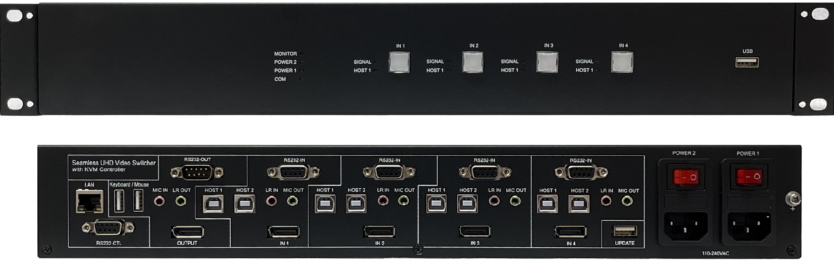

**warning警告**

* 请勿将本设备暴露在雨水、湿气和滴水中
* 请使用随机配送的附件
* 在闪电雷暴天气下，请拔掉电源

内容

1. 特点 3

2. 面板 4

3. EDID 处理 6

4. 视频和音频 6

5. 键盘热键 7

6. 规格 7

7. 包装 7

8. RS232 命令 7

System command 8

Switching command 9

Output command 9

Audio command 10

EDID command 11

Status command 11

**介绍**

本产品是一款4x1超高清无缝切换器,支持4台电脑的DP视频信号及KVM控制，支持麦克风及左右声道模拟音频的输入输出，支持USB 2.0及键盘鼠标，支持4路RS232串口信号的切换选择

# 特点

* 4路电脑的KVM信号输入，支持DP1.2
* 不同的视频源间无缝切换， 最大视频分辨率 3840x2160p60
* 每个KVM设备支持两路USB HOST输入， 其中HOST 1用来接键盘鼠标，HOST 2用来接USB 2.0设备
* 1路麦克风输入，4路麦克风输出
* 4路DP视频信号/RS232信号/USB信号/左右声道音频信号同步切换
* KVM切换时，键盘鼠标无需重新建立连接，无卡顿或等待时间
* 可以通过RS232串口，网口，前面板以及键盘热键进行KVM切换
* 支持双电源冗余功能

# 面板

前面板



| **名称** | **说明** |
| --- | --- |
| **MONITOR 灯** | 显示设备正常接入本设备时灯亮 |
| **POWER 2灯** | 电源2接入时灯亮 |
| **POWER 1灯** | 电源1接入时灯亮 |
| **COM 灯** | 网口或串口与本设备进行通信时灯闪烁 |
| **IN 1** | 输入1选择带灯按键及两个LED指示灯，当选择这路信号时，按键内部的灯会点亮；当这一路输入有信号时，SIGNAL灯会点亮; 当这一路的HOST 1有接入时（用来接键盘或鼠标），HOST 1灯会点亮  长按IN 1按键3秒，切换输出分辨率至2048x2048p60 |
| **IN 2** | 输入2选择带灯按键及两个LED指示灯，当选择这路信号时，按键内部的灯会点亮；当这一路输入有信号时，SIGNAL灯会点亮; 当这一路的HOST 1有接入时（用来接键盘或鼠标），HOST 1灯会点亮  长按IN 2按键3秒，切换输出分辨率至3840x2160p60 |
| **IN 3** | 输入3选择带灯按键及两个LED指示灯，当选择这路信号时，按键内部的灯会点亮；当这一路输入有信号时，SIGNAL灯会点亮; 当这一路的HOST 1有接入时（用来接键盘或鼠标），HOST 1灯会点亮  长按IN 3按键3秒，切换输出分辨率至1920x1080p60 |
| **IN 4** | 输入4选择带灯按键及两个LED指示灯，当选择这路信号时，按键内部的灯会点亮；当这一路输入有信号时，SIGNAL灯会点亮; 当这一路的HOST 1有接入时（用来接键盘或鼠标），HOST 1灯会点亮  长按IN 4按键3秒，恢复出厂设置 |
| **USB** | 用来接入USB设备，支持到USB2.0 |

后面板

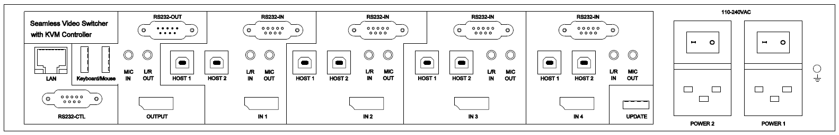

|  |  |
| --- | --- |
| **名称** | **说明** |
| **LAN,RS232-CTL** | 网口控制和RS232串口控制， 波特率9600  默认网络参数如下，可通过指令修改：  IP Address: 192.168.0.247  SUBMASK: 255.255.255.0  GATEWAY:192.168.0.1  NETPORT: 2000 |
| **MIC IN** | 麦克风输入，仅支持MIC-LINE信号， 不支持驻极体等麦克风 |
| **MIC OUT** | 麦克风输出，信号强度为MIC-LINE 输出 |
| **RS232** OUT | DB9公头,4路RS232信号经过4选1切换后接入这个口 |
| **Keyboard/Mouse** | 接入键盘鼠标 |
| **HOST 1,2** | 接入PC的两个USB口，HOST 1用来做键盘鼠标控制用，HOST 2用来接入其它USB设备 |
| **L/R IN** | 左右声道音频输入 |
| **MIC OUT** | 麦克风输出 |
| **RS232 IN** | DB9母座， 4个连接PC的RS232口 |
| **UPDATE** | USB升级口，可接入U盘升级 |
| **POWER 1,2** | 双电源冗余输入， 可接入其中一路或两路同时接入 |

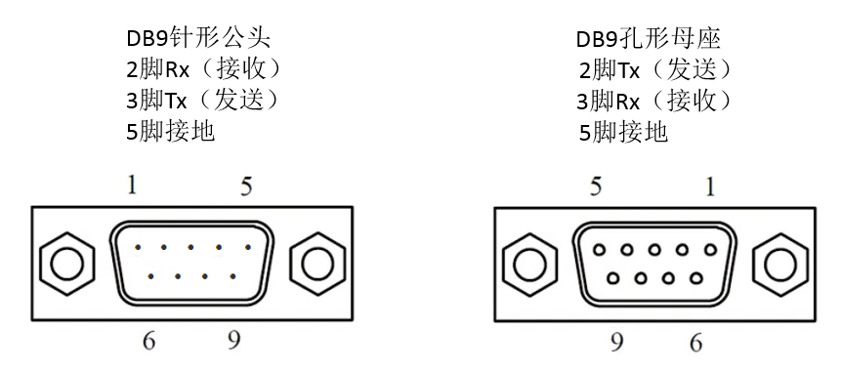

# EDID 处理

用户可以通过串口指令选择以下EDID模式

|  |  |  |  |
| --- | --- | --- | --- |
| **Number** | **EDID mode** | **Number** | **EDID mode** |
| **1** | 4K60-2.0CH | 8 | 1600x1200 |
| **2** | 2048x2048 | 9 | 1440x900 |
| **3** | 4K30-2.0CH | 10 | 1360x768 |
| **4** | 1080P-2.0CH | 11 | 1280x1024 |
| **5** | 720P | 12 | 1024x768 |
| **6** | 1920x1200 | 13 | AUTO |
| **7** | 1680x1050 | 14 | USER |

# 视频和音频

本设备支持最大到3840x2160p60视频分辨率输入，支持以下可选的分辨率输出

|  |  |  |  |
| --- | --- | --- | --- |
| **Number** | **Output Resolution** | **Number** | **Output Resolution** |
| **1** | 4096x2160p 60Hz | 8 | 1920x1080p 60Hz |
| **2** | 4096x2160p 50Hz | 9 | 1920x1080p 50Hz |
| **3** | 3840x2160p 60Hz | 10 | 1360x768p 60Hz |
| **4** | 3840x2160p 50Hz | 11 | 1280x800p 60Hz |
| **5** | 3840x2160p 30Hz | 12 | 1280x720p 60Hz |
| **6** | 2048x2048p 60Hz | 13 | 1280x720p 50Hz |
| **7** | 1920x1200p60Hz RB | 14 | 1024x768 60Hz |

支持DP信号内嵌音频解嵌输出，以及外部模拟音频加嵌输入， DP输出和模拟音频输出可选外部音频和DP内嵌音频，也可以分别取自身的音频

# 键盘热键

Ctrl + Ctrl + 1表示切换KVM信号至IN 1，同理可切换至IN 2,3,4

Ctrl + Ctrl + 0表示返回上一次信号源

这里的 “+”表示操作上的先后顺序

# 规格

|  |  |
| --- | --- |
| 带宽 | 594MHz (18Gbps), DP1.2 |
| 输入口 | 4路DP,1路麦克风，4路RS232,  2x4路USB-HOST,4路模拟音频 |
| 输出口 | 1路DP， 4路麦克风，1路RS232，1路USB 2.0, 1路键盘和鼠标 |
| 交流电源 | 110-220VAC |
| 工作温度 | 0 to +40°C (+32 to +104 °F) |
| 工作湿度 | 10 to 70 % RH (non-condensing) |
| ESD | Air: ± 8KV, Contact: ± 4KV, |
| 尺寸 | L430 x W220 x H67 mm |
| 重量 | 7kg |

# 包装

|  |  |
| --- | --- |
| **内容** | **数量** |
| 切换器 | 1 |
| 电源线 | 2 |

# RS232 命令

注意: 所有的命令都以 SET 或 GET开始, 以回车符CR结束，⮠ 代表回车符CR(**ASCII编码值为0x0D**)

Baud Rate: 9600, Data Bits:8, Parity: None Stop Bits:1

## System command

|  |  |
| --- | --- |
| Command | Details |
| GET HELP⮠ | Get the Commands list |
| SET RESET⮠ | Recover to default setting |
| GET VERSION⮠ | Get firmware version  Return: VERSION w⮠ (w is version number) |
| GET MODEL TYPE⮠ | Get device model name  Return: MODEL TYPE KVM41DP⮠ |
| SET BAUDRATE w⮠ | w is 9600, 19200, 38400,57600 or 115200  Return: BAUDRATE w⮠ |
| GET BAUDRATE w⮠ | Return: BAUDRATE w⮠ |
| GET POWER1⮠ | Return: POWER1 ON or OFF⮠ |
| GET POWER2 | Return: POWER2 ON or OFF⮠ |
| SET IP ADDRESS w⮠ | For example: SET IP ADDRESS 192.168.0.247  Return: IP ADDRESS w⮠ |
| GET IP ADDRESS⮠ | Return: IP ADDRESS w⮠ |
| SET SUBMASK w⮠ | For example: SET SUBMASK 255.255.255.0  Return: SUBMASK w⮠ |
| GET SUBMASK⮠ | Return: SUBMASK w⮠ |
| SET GATEWAY w⮠ | For example: SET GATEWAY 192.168.0.1  Return: GATEWAY w⮠ |
| GET GATEWAY⮠ | Return: GATEWAY w⮠ |
| SET NETPORT w⮠ | For example: SET NETPORT 2000  Return: NETPORT w⮠ |
| GET NETPORT⮠ | Return: NETPORT w⮠ |
| SET NETWORK-INFO IP PORT SUBMASK GATEWAY⮠ | For Example:  SET NETWORK-INFO 192.168.0.247 2000 255.255.255.0 192.168.0.1⮠  Return: NETWORK-INFO 192.168.0.247 2000 255.255.255.0 192.168.0.1⮠ |
| GET NETWORK-INFO⮠ | Return: NETWORK-INFO IP PORT SUBMASK GATEWAY⮠ |

## Switching command

|  |  |
| --- | --- |
| Commands | Details |
| SET IN SOURCE w⮠ | w is one of the following:  IN1, IN2, IN3, IN4,  Return: IN SOURCE w⮠ |
| GET IN SOURCE⮠ | Get current input channel selection information  Return: IN SOURCE w⮠ |
| GET IN RESOLUTION⮠ | Get current input resolution  Return: IN RESOLUTION w⮠ (w is input resolution) |

## Output command

|  |  |
| --- | --- |
| Commands | Details |
| SET OUT RESOLUTION w⮠ | w is one of the following, default: Auto  4096x2160p60, 4096x2160p50,  3840x2160p60, 3840x2160p50,  3840x2160p30, 2048x2048p60,  1920x1200p60RB, 1920x1080p60,  1920x1080p50, 1360x768p60,  1280x800p60, 1280x720p60,  1280x720p50, 1024x768p60,  Auto,  Return: OUT RESOLUTION w⮠ |
| GET OUT RESOLUTION⮠ | Get current output resolution setting  Return: OUT RESOLUTION w⮠ |
| SET OUT VKA w⮠ | Set video keep alive mode  w is BLUESCREEN or BLACKSCREEN.  Default BLACKSCREEN. It is for no signal display  Return: OUT VKA w⮠ |
| GET OUT VKA⮠ | Return: OUT VKA w⮠ |
| SET OUT ITC w⮠ | w is ON or OFF, default OFF  Return: OUT ITC w⮠  Suggest **OFF** for video display and **ON** for PC especially desktop display, default **OFF** |
| GET OUT ITC⮠ | Return: OUT ITC w⮠ |

## Audio command

|  |  |
| --- | --- |
| Commands | Details |
| SET AUDIO SRCw⮠ | Audio selection, w is EACH，LR or INNER,  default EACH  EACH means DP output with input DP INNER audio, LR output with LR INPUT audio |
| GET AUDIO SRC⮠ | Return: AUDIO SOURCE w⮠ |

## EDID command

The following commands are used to set EDID mode for the inputs

|  |  |
| --- | --- |
| Commands | Details |
| SET IN EDIDMODE w⮠ | w is one of the following:  4K60-2.0, 2048x2048, 4K30-2.0, 1080p60-2.0,  1920x1200, 1680x1050, 1600x1200, 1440x900, 1360x768, 1280x1024, 1024x768, 720p, AUTO,USER  Default: AUTO  Return: IN EDIDMODE w⮠ |
| SET EDID-USER w⮠ | Switcher can only support 256 bytes EDID-USER data.  w is 256 bytes EDID data.  Return: EDID-USER OK⮠ |
| GET IN EDIDMODE⮠ | Return: IN EDIDMODE w⮠ |

## Status command

The following commands are used to get the status of the switcher

|  |  |
| --- | --- |
| Commands | Details |
| GET IN STATUS⮠ | Get the switcher input status(VALID/INVALID)  Return:  IN STATUS IN1 VALID⮠  IN STATUS IN2 INVALID⮠  IN STATUS IN3 INVALID⮠  IN STATUS IN4 VALID⮠ |
| GET OUT STATUS⮠ | Get the switcher output status(VALID/INVALID)  Return: **OUT** STATUS OUT VALID⮠ |
| GET POWER STATUS⮠ | Get the switcher power status(VALID/INVALID)  Return:  POWER STATUS POWER1 VALID⮠  POWER STATUS POWER2 INVALID⮠ |
| GET HOST STATUS⮠ | Get the switcher host status(VALID/INVALID)  Return:  HOST STATUS IN1-HOST1 VAILD⮠  HOST STATUS IN2-HOST1 INVALID⮠  HOST STATUS IN3-HOST1 INVALID⮠  HOST STATUS IN4-HOST1 INVALID⮠ |